Preparation of Papers for IJISAE
Author 1¹, Author*², Author³

Submitted: xx/xx/202x Accepted : xx/xx/201x DOI: 10.1039/b000000x
_______________________________________________________________________________________________________________________________________________________________________________________________________________________________________________________________________________________________________________________________
¹ S.D.M.College of Eng. &Tech, Fort Collins – 8023, USA
ORCID ID : 0000-3343-7165-777X
² KLE.Institute of Technology, Tsukuba – 80309, JAPAN
ORCID ID : 0000-3343-7165-777X
³ Computer Eng., Selcuk University, Konya – 42002, TURKEY
ORCID ID : 0000-3343-7165-777X
* Corresponding Author Email: author@email.com
Abstract: These instructions give you guidelines for preparing papers for IJISAE. Use this document as a template if you are using Microsoft Word 2007 or later. Otherwise, use this document as an instruction set. Paper titles should be written in uppercase and lowercase letters, not all uppercase. Avoid writing long formulas with subscripts in the title; short formulas that identify the elements are fine (e.g., "Nd–Fe–B"). Do not write “(Invited)” in the title. Full names of authors are preferred in the author field, but are not required. Put a space between authors’ initials. The abstract must be a concise yet comprehensive reflection of what is in your article. In particular, the abstract must be self-contained, without abbreviations, footnotes, or references. It should be a microcosm of the full article. The abstract must be between 150–250 words. Be sure that you adhere to these limits; otherwise, you will need to edit your abstract accordingly. The abstract must be written as one paragraph, and should not contain displayed mathematical equations or tabular material. The abstract should include three or four different keywords or phrases, as this will help readers to find it. It is important to avoid over-repetition of such phrases as this can result in a page being rejected by search engines. Ensure that your abstract reads well and is grammatically correct.
Keywords: Enter key words or phrases in alphabetical order, separated by commas

- Introduction
This template, modified in MS Word 2007 and saved as a “Word 97-2003 Document” for the PC, provides authors with most of the formatting specifications needed for preparing electronic versions of their papers. All standard paper components have been specified for three reasons: ease of use when formatting individual papers, automatic compliance to electronic requirements that facilitate the concurrent or later production of electronic products, and conformity of style throughout a manuscripts. Margins, column widths, line spacing, and type styles are built-in; examples of the type styles are provided throughout this document and are identified in italic type, within parentheses, following the example. Some components, such as multi-leveled equations, graphics, and tables are not prescribed, although the various table text styles are provided. The formatter will need to create these components, incorporating the applicable criteria that follow.
  - Abbreviations and Acronyms
Define abbreviations and acronyms the first time they are used in the text, even after they have already been defined in the abstract. Abbreviations such as IEEE, SI, ac, and dc do not have to be defined. Abbreviations that incorporate periods should not have spaces: write “C.N.R.S.,” not “C. N. R. S.” Do not use abbreviations in the title unless they are unavoidable (for example, “IEEE” in the title of this article).
  - Other Recommendations
Use one space after periods and colons. Hyphenate complex modifiers: “zero-field-cooled magnetization.” Avoid dangling participles, such as, “Using (1), the potential was calculated.” [It is not clear who or what used (1).] Write instead, “The potential was calculated by using (1),” or “Using (1), we calculated the potential.”
Use a zero before decimal points: “0.25,” not “.25.” Use “cm³,” not “cc.” Indicate sample dimensions as “0.1 cm × 0.2 cm,” not “0.1 × 0.2 cm².” The abbreviation for “seconds” is “s,” not “sec.” Use “Wb/m²” or “webers per square meter,” not “webers/m².” When expressing a range of values, write “7 to 9” or “7-9,” not “7~9.”
A parenthetical statement at the end of a sentence is punctuated outside of the closing parenthesis (like this). (A parenthetical sentence is punctuated within the parentheses.) In American English, periods and commas are within quotation marks, like “this period.” Other punctuation is “outside”! Avoid contractions; for example, write “do not” instead of “don’t.” The serial comma is preferred: “A, B, and C” instead of “A, B and C.”
If you wish, you may write in the first person singular or plural and use the active voice (“I observed that ...” or “We observed that ...” instead of “It was observed that ...”). Remember to check spelling. If your native language is not English, please get a native English-speaking colleague to carefully proofread your paper.
- MATH
If you are using Word, use either the Microsoft Equation Editor or the MathType add-on (http://www.mathtype.com) for equations in your paper (Insert | Object | Create New | Microsoft Equation or MathType Equation). “Float over text” should not be selected.
  - Equations
Number equations consecutively with equation numbers in parentheses flush with the right margin, as in (1). First use the equation editor to create the equation. Then select the “Equation” markup style. Press the tab key and write the equation number in parentheses. To make your equations more compact, you may use the solidus ( / ), the exp function, or appropriate exponents. Use parentheses to avoid ambiguities in denominators. Punctuate equations when they are part of a sentence, as in
$f\left(x\right)=a_{0}+\sum_{n=1}^{∞}{\left(a_{n}\cos{\frac{nπx}{L}}+b_{n}\sin{\frac{nπx}{L}}\right)}$ (1)
${\left(x+a\right)}^{n}=\sum_{k=0}^{n}{\left({n \atop k}\right)x^{k}a^{n-k}}$ (2)
Be sure that the symbols in your equation have been defined before the equation appears or immediately following. Italicize symbols (T might refer to temperature, but T is the unit tesla). Refer to “(1),” not “Eq. (1)” or “equation (1),” except at the beginning of a sentence: “Equation (1) is ... .”
- Units
Use either SI (MKS) or CGS as primary units. (SI units are strongly encouraged.) English units may be used as secondary units (in parentheses). This applies to papers in data storage. For example, write “15 Gb/cm² (100 Gb/in²).” An exception is when English units are used as identifiers in trade, such as “3½-in disk drive.” Avoid combining SI and CGS units, such as current in amperes and magnetic field in oersteds. This often leads to confusion because equations do not balance dimensionally. If you must use mixed units, clearly state the units for each quantity in an equation.
The SI unit for magnetic field strength H is A/m. However, if you wish to use units of T, either refer to magnetic flux density B or magnetic field strength symbolized as µ₀H. Use the center dot to separate compound units, e.g., “A·m².”
- Some Common Mistakes
The word “data” is plural, not singular. The subscript for the permeability of vacuum µ₀ is zero, not a lowercase letter “o.” The term for residual magnetization is “remanence”; the adjective is “remanent”; do not write “remnance” or “remnant.” Use the word “micrometer” instead of “micron.” A graph within a graph is an “inset,” not an “insert.” The word “alternatively” is preferred to the word “alternately” (unless you really mean something that alternates). Use the word “whereas” instead of “while” (unless you are referring to simultaneous events). Do not use the word “essentially” to mean “approximately” or “effectively.” Do not use the word “issue” as a euphemism for “problem.” When compositions are not specified, separate chemical symbols by en-dashes; for example, “NiMn” indicates the intermetallic compound Ni_{0.5}Mn_{0.5} whereas “Ni–Mn” indicates an alloy of some composition Ni_{x}Mn_{1-x}.
Table 1. Example of full page table
Fungal Symptom | Causal organism | Family | Order | Class | Subdivision | Affected part
Mango Anthracnose | Glomerella cingulata | Glomerellaceae | Incertaesedis | Sordariomycetes | Sordariomycetidae | stem, leaf, fruit
Mango Powdery mildew | Oidium mangiferae | Erysiphaceae | Erysiphales | Leotiomycetes | Leotiomycetidae | stem, leaf, fruit
Pomegranate Anthracnose | Glomerella cingulata | Glomerellaceae | Melanconiales | Sordariomycetes | Pezizomycotina | stem, leaf, fruit
Grape Anthracnose | Elsinoë ampelina | Elsinoaceae | Incertaesedis | Dothideomycetes | Dothideomycetidae | stem, leaf, fruit

Be aware of the different meanings of the homophones “affect” (usually a verb) and “effect” (usually a noun), “complement” and “compliment,” “discreet” and “discrete,” “principal” (e.g., “principal investigator”) and “principle” (e.g., “principle of measurement”). Do not confuse “imply” and “infer.”
Prefixes such as “non,” “sub,” “micro,” “multi,” and “ultra” are not independent words; they should be joined to the words they modify, usually without a hyphen. There is no period after the “et” in the Latin abbreviation “et al.” (it is also italicized). The abbreviation “i.e.,” means “that is,” and the abbreviation “e.g.,” means “for example” (these abbreviations are not italicized).
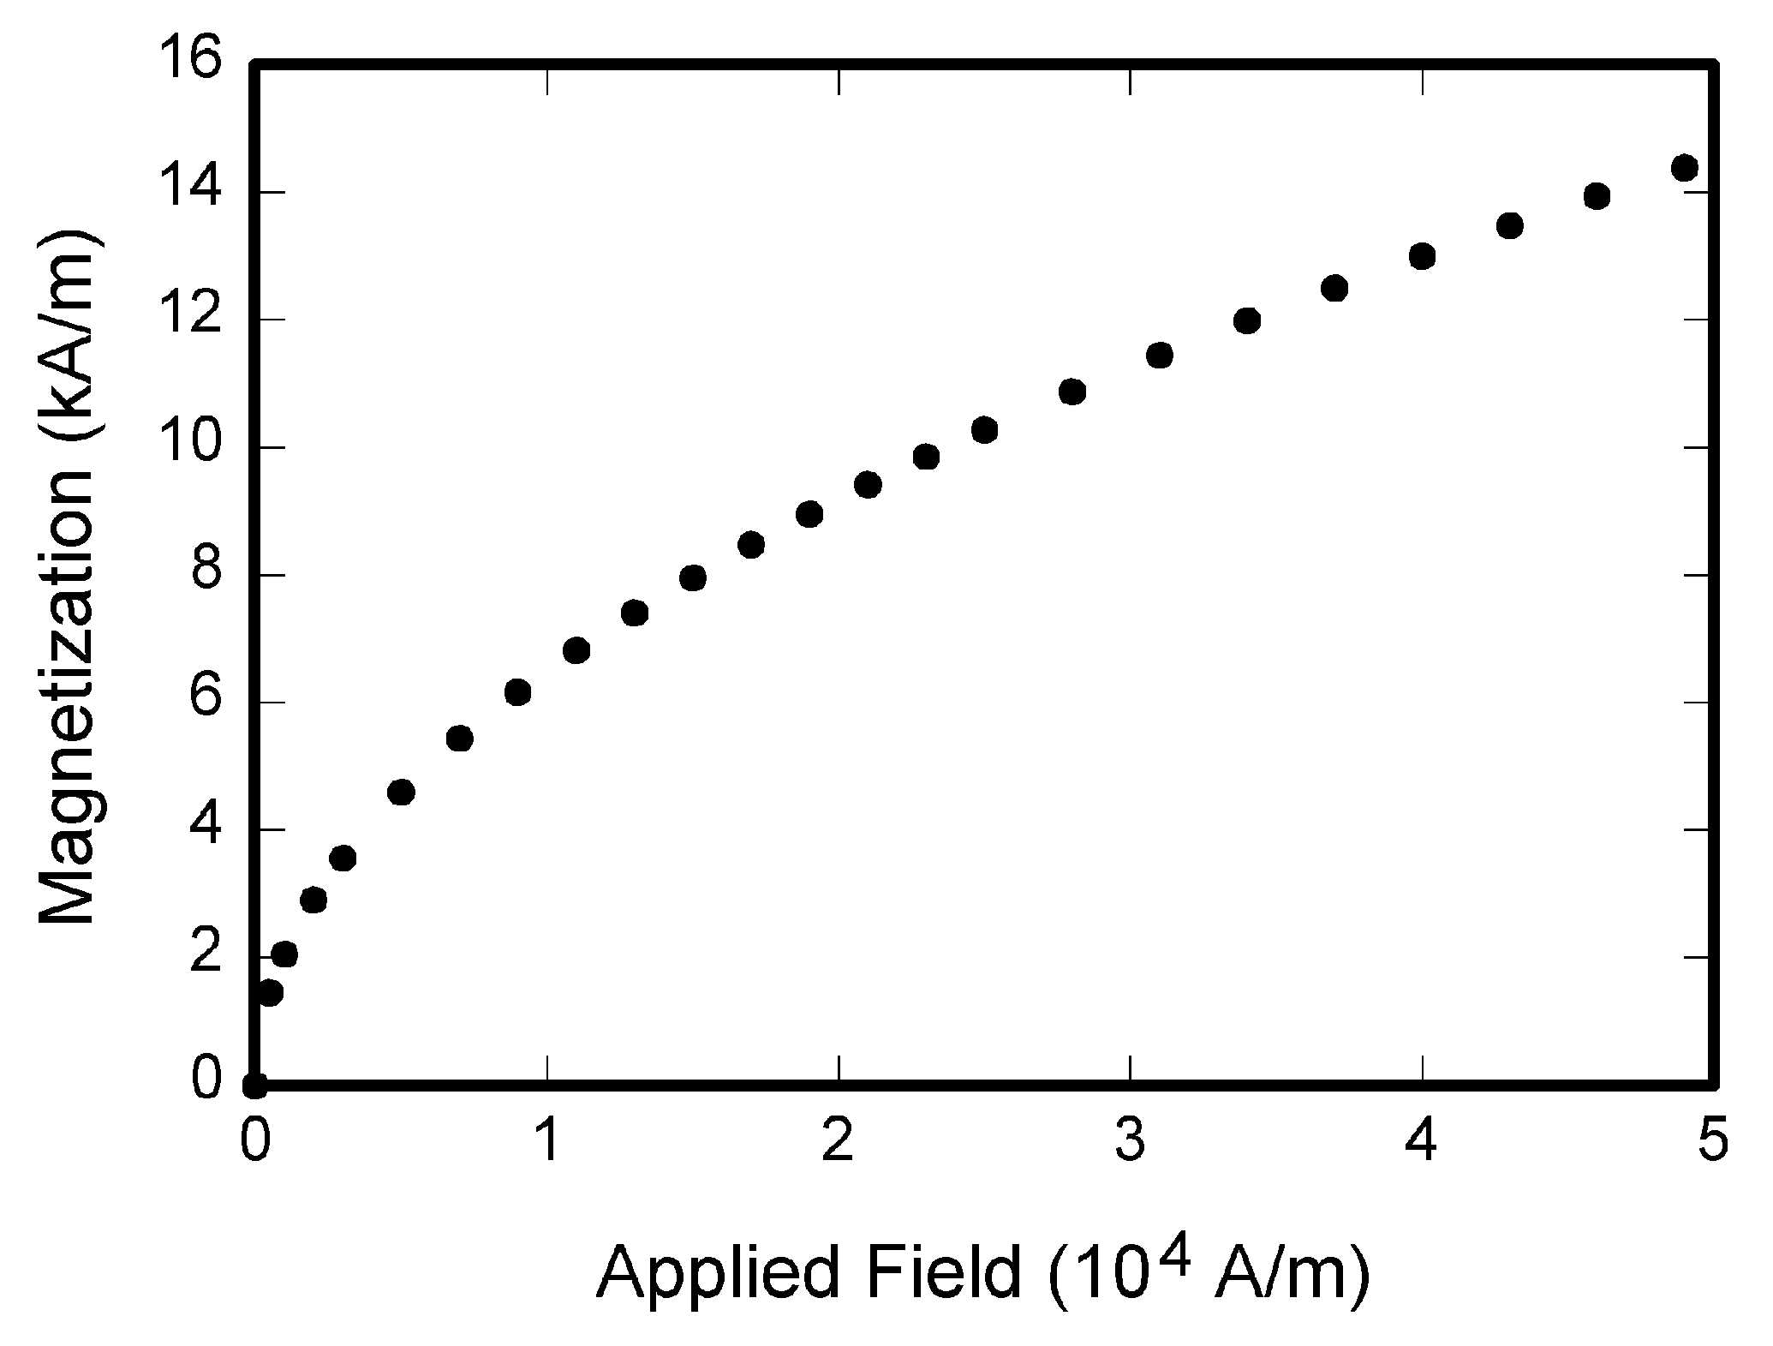
Fig. 1. Magnetization as a function of applied field. Note that “Fig.” is abbreviated. There is a period after the figure number, followed by two spaces. It is good practice to explain the significance of the figure in the caption.
- Guidelines for Graphics Preparation and Submission
  - Types of Graphics
The following list outlines the different types of graphics published in IEEE journals. They are categorized based on their construction, and use of color / shades of gray:
    - Color/Grayscale figures
Figures that are meant to appear in color, or shades of black/gray. Such figures may include photographs, illustrations, multicolor graphs, and flowcharts.
    - Line Art figures
Figures that are composed of only black lines and shapes. These figures should have no shades or half-tones of gray, only black and white.
    - Tables
Data charts which are typically black and white, but sometimes include color.
Table 2. Units for magnetic properties
Symbol | Quantity | Conversion from Gaussian and  CGS EMU to SI ª
Φ | magnetic flux | 1 Mx → 10⁻⁸ Wb = 10⁻⁸ V·s
B | magnetic flux density,  magnetic induction | 1 G → 10⁻⁴ T = 10⁻⁴ Wb/m²
H | magnetic field strength | 1 Oe → 10³/(4π) A/m
χ, κ | susceptibility | 1 → 4π
χ_{ρ} | mass susceptibility | 1 cm³/g → 4π × 10⁻³ m³/kg
μ | permeability | 1 → 4π × 10⁻⁷ H/m  = 4π × 10⁻⁷ Wb/(A·m)
μ_{r} | relative permeability | μ → μ_{r}
w, W | energy density | 1 erg/cm³ → 10⁻¹ J/m³
N, D | demagnetizing factor | 1 → 1/(4π)
Vertical lines are optional in tables. Statements that serve as captions for the entire table do not need footnote letters. aGaussian units are the same as cg emu for magnetostatics; Mx = maxwell, G = gauss, Oe = oersted; Wb = weber, V = volt, s = second, T = tesla, m = meter, A = ampere, J = joule, kg = kilogram, H = henry.
  - Multipart figures
Figures compiled of more than one sub-figure presented side-by-side, or stacked. If a multipart figure is made up of multiple figure types (one part is lineart, and another is grayscale or color) the figure should meet the stricter guidelines.
  - File Formats For Graphics
Format and save your graphics using a suitable graphics processing program that will allow you to create the images as PostScript (PS), Encapsulated PostScript (.EPS), Tagged Image File Format (.TIFF), Portable Document Format (.PDF), or Portable Network Graphics (.PNG) sizes them, and adjusts the resolution settings. If you created your source files in one of the following programs you will be able to submit the graphics without converting to a PS, EPS, TIFF, PDF, or PNG file: Microsoft Word, Microsoft PowerPoint, or Microsoft Excel. Though it is not required, it is strongly recommended that these files be saved in PDF format rather than DOC, XLS, or PPT. Doing so will protect your figures from common font and arrow stroke issues that occur when working on the files across multiple platforms. When submitting your final paper, your graphics should all be submitted individually in one of these formats along with the manuscript.
  - Sizing of Graphics
Most charts, graphs, and tables are one column wide or page wide. When choosing the depth of a graphic, please allow space for a caption. Figures can be sized between column and page widths if the author chooses, however it is recommended that figures are not sized less than column width unless when necessary.
  - Resolution
The proper resolution of your figures will depend on the type of figure it is as defined in the “Types of Figures” section. Author photographs, color, and grayscale figures should be at least 300dpi. Line art, including tables should be a minimum of 600dpi.
  - Vector Art
In order to preserve the figures’ integrity across multiple computer platforms, we accept files in the following formats: .EPS/.PDF/.PS. All fonts must be embedded or text converted to outlines in order to achieve the best-quality results.
  - Color Space
The term color space refers to the entire sum of colors that can be represented within the said medium. For our purposes, the three main color spaces are Grayscale, RGB (red/green/blue) and CMYK (cyan/magenta/yellow/black). RGB is generally used with on-screen graphics, whereas CMYK is used for printing purposes.
All color figures should be generated in RGB or CMYK color space. Grayscale images should be submitted in Grayscale color space. Line art may be provided in grayscale OR bitmap colorspace. Note that “bitmap colorspace” and “bitmap file format” are not the same thing. When bitmap color space is selected, .TIF/.TIFF/.PNG are the recommended file formats.
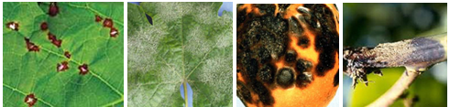
Fig 2. Images showing the visual symptoms cause by fungal disease
  - Accepted Fonts Within Figures
When preparing your graphics IEEE suggests that you use of one of the following Open Type fonts: Times New Roman, Helvetica, Arial, Cambria, and Symbol. If you are supplying EPS, PS, or PDF files all fonts must be embedded. Some fonts may only be native to your operating system; without the fonts embedded, parts of the graphic may be distorted or missing.
A safe option when finalizing your figures is to strip out the fonts before you save the files, creating “outline” type. This converts fonts to artwork what will appear uniformly on any screen.
  - Using Labels Within Figures
    - Figure Axis labels
Figure axis labels are often a source of confusion. Use words rather than symbols. As an example, write the quantity “Magnetization,” or “Magnetization M,” not just “M.” Put units in parentheses. Do not label axes only with units. As in Fig. 1, for example, write “Magnetization (A/m)” or “Magnetization (Am⁻¹),” not just “A/m.” Do not label axes with a ratio of quantities and units. For example, write “Temperature (K),” not “Temperature/K.”
Multipliers can be especially confusing. Write “Magnetization (kA/m)” or “Magnetization (10³ A/m).” Do not write “Magnetization (A/m) × 1000” because the reader would not know whether the top axis label in Fig. 1 meant 16000 A/m or 0.016 A/m. Figure labels should be legible, approximately 8 to 10 point type.
    - Subfigure Labels in Multipart Figures and Tables
Multipart figures should be combined and labeled before final submission. Labels should appear centered below each subfigure in 8 point Times New Roman font in the format of (a) (b) (c).
    - Referencing a Figure or Table Within Your Paper
When referencing your figures and tables within your paper, use the abbreviation “Fig.” even at the beginning of a sentence. Do not abbreviate “Table.” Tables should be numbered with Roman Numerals.
- Conclusion
A conclusion might elaborate on the importance of the work or suggest applications and extensions.
  - Appendix
Appendixes, if needed, appear before the acknowledgment.
  - Acknowledgment
The preferred spelling of the word “acknowledgment” in American English is without an “e” after the “g.” Use the singular heading even if you have many acknowledgments. Avoid expressions such as “One of us (S.B.A.) would like to thank ... .” Instead, write “F. A. Author thanks ... .” In most cases, sponsor and financial support acknowledgments are placed in the unnumbered footnote on the first page, not here.
- References and Footnotes
  - References
References need not be cited in text. When they are, they appear on the line, in square brackets, inside the punctuation. Multiple references are each numbered with separate brackets. When citing a section in a book, please give the relevant page numbers. In text, refer simply to the reference number. Do not use “Ref.” or “reference” except at the beginning of a sentence: “Reference [3] shows ... .” Please do not use automatic endnotes in Word, rather, type the reference list at the end of the paper using the “References” style.
Reference numbers are set flush left and form a column of their own, hanging out beyond the body of the reference. The reference numbers are on the line, enclosed in square brackets. In all references, the given name of the author or editor is abbreviated to the initial only and precedes the last name. Use them all; use et al. only if names are not given. Use commas around Jr., Sr., and III in names. Abbreviate conference titles. When citing IEEE transactions, provide the issue number, page range, volume number, year, and/or month if available. When referencing a patent, provide the day and the month of issue, or application. References may not include all information; please obtain and include relevant information. Do not combine references. There must be only one reference with each number. If there is a URL included with the print reference, it can be included at the end of the reference.
Other than books, capitalize only the first word in a paper title, except for proper nouns and element symbols. For papers published in translation journals, please give the English citation first, followed by the original foreign-language citation See the end of this document for formats and examples of common references.
Acknowledgements
This research was supported/partially supported by [Name of Foundation, Grant maker, Donor]. We thank our colleagues from [Name of the supporting institution] who provided insight and expertise that greatly assisted the research, although they may not agree with all of the interpretations/conclusions of this paper. We thank [Name Surname, title] for assistance with [particular technique, methodology], and [Name Surname, position, institution name] for comments that greatly improved the manuscript.
Author contributions
Name1 Surname1: Conceptualization, Methodology, Software, Field study Name2 Surname2: Data curation, Writing-Original draft preparation, Software, Validation., Field study Name3 Surname3: Visualization, Investigation, Writing-Reviewing and Editing.
Conflicts of interest
The authors declare no conflicts of interest.

References
References should be written like this. Please do not use any web-site [URL] as a citation. Do not put an empty line between references.
2nd ed., vol. 3, J. Peters, Ed. New York, NY, USA: McGraw-Hill, 1964, pp. 15–64.
W.-K. Chen, Linear Networks and Systems. Belmont, CA, USA: Wadsworth, 1993, pp. 123–135.
J. U. Duncombe, “Infrared navigation—Part I: An assessment of feasibility,” IEEE Trans. Electron Devices, vol. ED-11, no. 1, pp. 34–39, Jan. 1959, 10.1109/TED.2016.2628402.
E. P. Wigner, “Theory of traveling-wave optical laser,” Phys. Rev., vol. 134, pp. A635–A646, Dec. 1965.
E. H. Miller, “A note on reflector arrays,” IEEE Trans. Antennas Propagat., to be published.
E. E. Reber, R. L. Michell, and C. J. Carter, “Oxygen absorption in the earth’s atmosphere,” Aerospace Corp., Los Angeles, CA, USA, Tech. Rep. TR-0200 (4230-46)-3, Nov. 1988.
J. H. Davis and J. R. Cogdell, “Calibration program for the 16-foot antenna,” Elect. Eng. Res. Lab., Univ. Texas, Austin, TX, USA, Tech. Memo. NGL-006-69-3, Nov. 15, 1987.
Transmission Systems for Communications, 3rd ed., Western Electric Co., Winston-Salem, NC, USA, 1985, pp. 44–60.
Motorola Semiconductor Data Manual, Motorola Semiconductor Products Inc., Phoenix, AZ, USA, 1989.
G. O. Young, “Synthetic structure of industrial plastics,” in Plastics, vol. 3, Polymers of Hexadromicon, J. Peters, Ed., 2nd ed. New York, NY, USA: McGraw-Hill, 1964, pp. 15-64. [Online]. Available: http://www.bookref.com.
The Founders’ Constitution, Philip B. Kurland and Ralph Lerner, eds., Chicago, IL, USA: Univ. Chicago Press, 1987. [Online]. Available: http://press-pubs.uchicago.edu/founders/
The Terahertz Wave eBook. ZOmega Terahertz Corp., 2014. [Online]. Available: http://dl.z-thz.com/eBook/zomega_ebook_pdf_1206_sr.pdf. Accessed on: May 19, 2014.
Philip B. Kurland and Ralph Lerner, eds., The Founders’ Constitution. Chicago, IL, USA: Univ. of Chicago Press, 1987, Accessed on: Feb. 28, 2010, [Online] Available: http://press-pubs.uchicago.edu/founders/
J. S. Turner, “New directions in communications,” IEEE J. Sel. Areas Commun., vol. 13, no. 1, pp. 11-23, Jan. 1995.
W. P. Risk, G. S. Kino, and H. J. Shaw, “Fiber-optic frequency shifter using a surface acoustic wave incident at an oblique angle,” Opt. Lett., vol. 11, no. 2, pp. 115–117, Feb. 1986.
P. Kopyt et al., “Electric properties of graphene-based conductive layers from DC up to terahertz range,” IEEE THz Sci. Technol., to be published. DOI: 10.1109/TTHZ.2016.2544142.
PROCESS Corporation, Boston, MA, USA. Intranets: Internet technologies deployed behind the firewall for corporate productivity. Presented at INET96 Annual Meeting. [Online]. Available: http://home.process.com/Intranets/wp2.htp
R. J. Hijmans and J. van Etten, “Raster: Geographic analysis and modeling with raster data,” R Package Version 2.0-12, Jan. 12, 2012. [Online]. Available: http://CRAN.R-project.org/package=raster
Teralyzer. Lytera UG, Kirchhain, Germany [Online]. Available: http://www.lytera.de/Terahertz_THz_Spectroscopy.php?id=home, Accessed on: Jun. 5, 2014
U.S. House. 102nd Congress, 1st Session. (1991, Jan. 11). H. Con. Res. 1, Sense of the Congress on Approval of Military Action. [Online]. Available: LEXIS Library: GENFED File: BILLS
Musical toothbrush with mirror, by L.M.R. Brooks. (1992, May 19). Patent D 326 189 [Online]. Available: NEXIS Library: LEXPAT File: DES
D. B. Payne and J. R. Stern, “Wavelength-switched pas- sively coupled single-mode optical network,” in Proc. IOOC-ECOC, Boston, MA, USA, 1985,
pp. 585–590.
D. Ebehard and E. Voges, “Digital single sideband detection for interferometric sensors,” presented at the 2nd Int. Conf. Optical Fiber Sensors, Stuttgart, Germany, Jan. 2-5, 1984.
G. Brandli and M. Dick, “Alternating current fed power supply,” U.S. Patent 4 084 217, Nov. 4, 1978.
J. O. Williams, “Narrow-band analyzer,” Ph.D. dissertation, Dept. Elect. Eng., Harvard Univ., Cambridge, MA, USA, 1993.
N. Kawasaki, “Parametric study of thermal and chemical nonequilibrium nozzle flow,” M.S. thesis, Dept. Electron. Eng., Osaka Univ., Osaka, Japan, 1993.

